Board Member Recruitment Pack-
Community Representatives

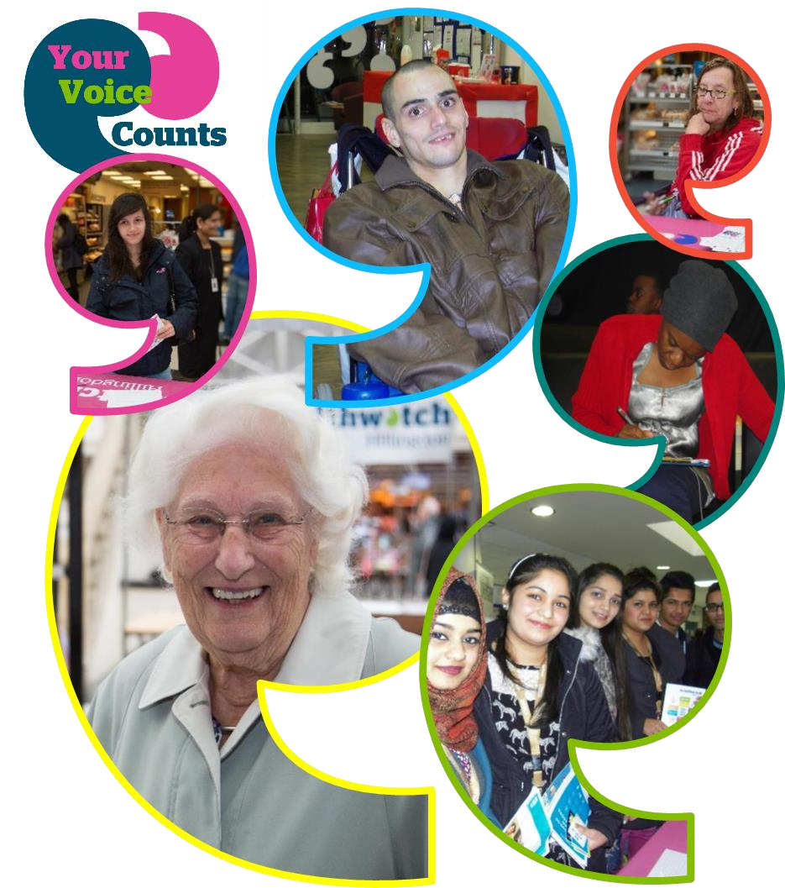

Purpose of this pack

This pack gives key information about our organisation and the role/ responsibilities of being a Community Representative Trustee. Please read this carefully before making your application.

If you wish to discuss any queries or questions you may have about the information and role of Trustee, please don’t hesitate to contact us.

Healthwatch Kirklees and Healthwatch Calderdale have established very strong relationships with the NHS, Council and voluntary sector organisations within our local areas. We are recognised as equal partners and a valued “critical friend” within the local health and social care system.
These important relationships enable us to have considerable input into shaping NHS and social care services, this gives people living in Kirklees and Calderdale a genuine platform to have their views and experiences heard by decision makers.
Healthwatch Kirklees and Healthwatch Calderdale are now looking to build on this success and are recruiting additional community representatives for our board of trustees.
This is an exciting opportunity to become involved in an award winning charity, as we look to increase our capacity and widen our reach to give more adults, young people, children and communities a stronger voice to influence and challenge how health and social care services are provided within local areas.
This pack provides details of the board membership recruitment, contains further background information on the position and details about how you can apply.
For an informal discussion about the position please contact Stacey Appleyard, Team Manager Healthwatch Kirklees on 01924 450379 or email stacey.appleyard@healthwatchkirklees.co.uk
The deadline for applications is 4th December 2020.
If you have any support requirements to enable you to apply, or require this recruitment pack in an alternative format, please contact Stacey Appleyard on the details above.
If you want to play a leading part in changing your community and shaping the future of health and social care in Kirklees and Calderdale, then we would be delighted to hear from you.

Yours faithfully
Paul Bridges
Chair

Application and Selection Process
The process has three stages –
- Firstly you will submit your application form to show your relevant experiences, interests and skills for the role;
- We will review your application and will then contact you to discuss the role and answer any questions you might have, this will be ‘the interview’. We will then make a decision and inform you and explain the next steps.
- Lastly you will be invited to our Annual General Meeting which will include a public showcase of our work throughout the past 12 months.
Applications are invited from people who are over the age of 18 and who live, or work, in Calderdale or Kirklees, or who can demonstrate a broad knowledge of the borough and health and social care issues and services. We would also like to hear from applicants who represent the diverse communities we have living in Kirklees and Calderdale.
We welcome applications from all suitably qualified persons regardless of their race, sex, disability, religion/belief, sexual orientation or age (18+).
Please read ALL the information in this pack to help you make your application.
For an informal discussion about the role, please contact Stacey Appleyard, Team Manager Healthwatch Kirklees on 01924 450379.

The deadline for applications for this role is 4th December 2020.
Email applications to: Stacey.appleyard@healthwatchkirklees.co.uk
or post to: Unit 11-12 Empire House, Wakefield Old Road, Dewsbury, WF12 8DJ

After identifying successful candidates through the recruitment process, eligibility will be assessed and references taken up, before formally offering a place on the Healthwatch Kirklees and Calderdale Trustee Board.

About Healthwatch Kirklees and Calderdale
Healthwatch Kirklees and Healthwatch Calderdale are ‘local Healthwatch organisations’ established in April 2013 under the Health and Social Care Act (2012). Our role is to act as a local, independent watchdog and a voice for people using NHS and social care services.
Healthwatch Kirklees and Calderdale has six core functions:
- Gathering the views and experiences of Calderdale and Kirklees patients, service users, carers and the public.
- Making those views known to providers and commissioners of services.
- Promoting and supporting the involvement of people in the commissioning and provision of local health and social care services and how they are scrutinised.
- Recommending investigations or special reviews via Healthwatch England or directly to the Care Quality Commission.
- Providing information and signposting about access to services and support for making informed choices including how to get independent advocacy support to make an NHS complaint.
- Informing Healthwatch England of the views and experiences of people, providing a steer to help it carry out its role as a national champion.
Independent of the NHS and Council, we represent the views of everyone who uses health and social care services in Calderdale and Kirklees. We make sure that these views are gathered, analysed and acted upon, making services better now and in the future.
We monitor local services to ensure they reflect the needs of the community, and where necessary, use statutory powers to hold those services to account.
We raise awareness amongst commissioners, providers and other agencies about the importance of engaging with communities, and the expertise and value that individuals can bring to discussion and decision making on local and national issues.
We promote community involvement in the commissioning, provision and scrutiny of health and social services, giving people and communities a stronger voice to influence and challenge how health and social care services are provided within their locality.
Healthwatch also provides or signposts people to information to help them make choices about health and social care services.
As part of a network of local Healthwatch from every local authority area in England, we are also uniquely placed to raise issues nationally through Healthwatch England.
To enable Healthwatch Kirklees and Healthwatch Calderdale to fulfil their functions we have a statutory seat on the Health and Well Being Board.
For more information about Healthwatch Calderdale or Healthwatch Kirklees visit:
www.healthwatchcalderdale.co.uk www.healthwatchkirklees.co.uk

Our Vision
Our vision is to become the influential and effective voice of the public.
We want to ensure that local decision makers and health and care services put the experiences of people at the heart of their work.
Give adults, young people, children and communities a greater say in - and the power to challenge - how health and social care services are run in Calderdale and Kirklees.
This vision is founded on the strong belief that services work best when they are designed around the needs and experiences of the people who use them.

Our Values as an Organisation and a Board.
We are inclusive
We are influential
We are responsible and accountable
We are independent
We are credible
We work collaboratively
We learn

Our Priorities
The focus of our work is established after undergoing an in-depth analysis of the data and intelligence gathered from residents living in Kirklees and Calderdale. The final priorities are agreed by the Trustee Board and set out in a published work-plan.

Our Structure
Healthwatch Kirklees and Calderdale are a company limited by guarantee and a registered charity:
Kirklees Company Number 08456146
Kirklees Registered Charity Number 1156338
Led by an independent Chair, The Healthwatch Kirklees and Healthwatch Calderdale Board can comprise of 5 Directors up to a maximum of 12. Board members are appointed following selection in an open recruitment process.
All Board members act as Directors and Trustees of Healthwatch Kirklees and Calderdale under the Companies Act 2006 and Charities Act 2011.

Time Commitment
It is expected that this role will require a minimum time commitment of approximately 1- 2 days a month, including responding to emails, reading and preparing for quarterly board meetings. This could increase to 3-4 days a month for those wishing to take on an executive role, or represent Healthwatch at other workshops, forums and strategic meetings. Meetings are held at alternate venues in Huddersfield and Halifax Town centres. Throughout the Covid-19 outbreak Board meetings will be held virtually.

Term
Appointments will be for a period of up to 3 years. Members will be eligible for re-appointment to serve a further 3 year term.

Remuneration
The role of Board members is voluntary and unpaid. All relevant expenses associated with the role are reimbursed in line with the volunteers expenses and benefits policy. If you require further information regarding our expenses policy please contact us on the information listed on page 2 of this document.

The Role, Responsibilities and Liabilities of Directors of the Board and its individual Board Members
Healthwatch Kirklees and Healthwatch Calderdale requires a Board of Directors that is capable of leading the organisation, providing strategic direction and oversight in all areas, including financial and legal matters, and in ensuring its ambition is achieved.
Each Healthwatch Board member must be eligible under law to be a company director and trustee, and who possesses the key values and skills required to steer Healthwatch Kirklees and Healthwatch Calderdale to success.
The Board will ensure that it meets the conditions of the contract held with Kirklees Council and Calderdale Council.
The Board will be collectively and individually responsible for seeing that:
- Healthwatch Kirklees and Healthwatch Calderdale are effectively managed and that its affairs are in order.
- That it operates within its objectives and governing documents.
- That it acts at all times in the best interests of the company/charity
- That it acts independently and promotes the voice of patients and the public in the specific local authorities.
- Provide strategic direction though annual plans, setting of policy and the development of strategies.
- Support the Chief Executive to manage staff and volunteers.
- Ensure adherence to the law, including company and when relevant, charity law. This includes preparing annual reports and submitting annual return forms and accounts.
- Secure sound financial management, including the meeting of all financial regulation and the auditing of accounts. It also includes ensuring the Board uses its funds and assets wisely to further its aims, and doesn’t do anything to put its property, funds, assets or reputation at risk and takes appropriate care and advice when investing or borrowing money.
- Assure itself that the organisation is run effectively, risks are mitigated, that services are delivered to required standards defined by beneficiaries, that there is a continuous improvement in quality and the organisation’s reputation is upheld.
- Effectively discharge its accountability duties to patients and the public, Healthwatch England, and other stakeholders. This includes maintaining effective working relationships with partner organisations.
- Maintain effectiveness of the Board itself, including overseeing the establishment of the organisation developing and ensuring compliance with codes of practice and maintaining appropriate standards of behaviour.

Liabilities
Directors of companies have additional statutory duties arising from their status under the Companies Act 2006. Healthwatch Kirklees and Healthwatch Calderdale is incorporated as a company limited by guarantee, this protects and limits the Director's liability to £1, except in exceptional circumstances.
Healthwatch Kirklees and Healthwatch Calderdale has indemnity insurance to indemnify any of the Directors from liability in the course of fulfilling their duties except for failures by the Board that cannot be insured against such as where a breach occurs resulting in a fine following criminal proceedings or penalty for non-compliance with regulatory requirements. Personal liability of this kind is very rare and Directors who have followed the guidance of the Companies Act and Charities Act will generally be protected.

Disclosure and Barring Service (DBS)
Healthwatch Kirklees and Healthwatch Calderdale Board members may need to undergo a DBS check (previously known as a CRB).

Conflicts of interest
Applicants should make very clear at the time of application whether any conflicts of interest, or potential conflicts of interest, may arise. These might include immediate family’s existing roles within Calderdale or Kirklees health and social care sector.
Likely conflicts of interests are:
Health or social care providers and their employees within Calderdale or Kirklees, or who supply health and social care services to people in the local area
Providers affiliated with a private company providing goods and services to local healthcare and social care providers
Commissioners of health and social care services in Calderdale and Kirklees
Elected members of Local or Central Government
Under the Companies Act 2006, anyone who fits one of the criteria below may not be a director:
Has been disqualified from acting as a company director (unless the court has given them permission to act for a particular company)
An undischarged bankrupt (unless they have been given permission by the court to act for a particular company)

Person Specification

Below are a range of skills, knowledge and attitudes that we wish to see in our Trustee Board members to ensure the Board is able to carry out its functions.

Please use these statements as a guide to writing your personal submission in the application – where you meet the essential (E) or desirable (D) statement try to make this clear in your statement.

We acknowledge that some of these criteria may only be partially met by applicants. This will not be a barrier to your application or interview for becoming a Trustee.

The role of Community Representative is a crucial one within the Board as it provides an independent voice and seeks to ensure that in the work of Healthwatch we take steps to represent all sections of the communities we serve.

1. Skills and Knowledge
Members need to be good communicators and be capable of playing an active role at regular meetings and contribute to the discussion informing policy decisions. (E)
Members will be able to communicate and engage with a range of different individuals from providers and commissioners to members of the public, and to liaise effectively and diplomatically, promoting collaborative working and acting as an ambassador for Healthwatch Kirklees and Healthwatch Calderdale. (E)
Members should have good analytical skills and awareness, in order to guide identification of gaps in patient and public feedback and in the provision and quality of local health and social care services. (E)
Members will play a lead role in determining Healthwatch Kirklees and Healthwatch Calderdale strategy, and how its budget is spent, so it is vital to demonstrate clear analytical skills and financial awareness to guide rational decision making to do this responsibly. (D)
Members will also need a basic knowledge of commissioning and procurement to support the provision and scrutiny of local services. (D)
Members are public representatives so they should have a good idea of what is expected from a position of civic responsibility. (E)
Members will need to work with health and social care providers to raise awareness of the role of local Healthwatch and capture and consolidate existing patient experience feedback. (E)
Members need to be able to take account of a wide range of views and to effectively represent the views of others, within the board and from local communities. (E)
Members should have an awareness of health and social care issues and policy and an understanding of the importance of public involvement in these issues. (D)
Members should have a sound grasp of equality legislation, its relevance and application. (D)
Members will need to demonstrate a clear understanding of sound governance principles in relation to Trusteeship. (E)
Members should have some knowledge of health and/or social care services. This could come from personal experience or a previous paid or unpaid role. (E)

2. Experience
Members will be responsible for overseeing reports and shaping projects so some experience of project management, report writing will be desirable. (D)
Members are expected to be active in their community and a track record of public engagement is desirable. (D)
Members to have experience of working as an effective member of a management board, committee or senior management team, influencing strategic decisions. (D)
Members should have experience of building and developing successful partnerships, alliances and working relationships, ideally with a range of organisations, stakeholders or communities. (D)
It is highly desirable for members to have had experience of public representation, particularly in health and social care. This may be as a representative of a service user group or acting as an advocate. (D)

3. Attitude and Approach
Members are tasked with acting in the public interest, and should therefore be public spirited and committed to the principle of championing the public’s interests in health and social care. (E)
Members need to be open-minded and inclusive, as Healthwatch Kirklees and Calderdale acts as a representative of the entire spectrum of the local population. (E)
Members need to have an active interest in how public involvement can shape health and social care services and have the desire to promote it (E)
Members need to have the will and desire to communicate effectively with all stakeholders and partners in fulfilling the Healthwatch role. (E)
Members should have a commitment to equality for all, including those protected within the Equalities Act, to promote human rights and to value diversity. (E)
Members must have personal credibility, integrity and honesty with a commitment to probity, to be independent of any special interest. (E)
Members must have transparency in their own motivation and actions and in supporting transparency in the workings of Healthwatch Kirklees and Calderdale. (E)

4. Other
Should live or work in Calderdale or Kirklees or be a user of local health and social care services, demonstrating an interest in and knowledge of the borough and a commitment to public/voluntary service. (D)
Be able to give a commitment of time and be willing to attend some evening and weekend meetings. (E)
Adhere to the Seven Principles of Public Life, known as the Nolan Principles (listed below), which were defined by the Committee for Standards in Public Life, and are adopted into Healthwatch Kirklees and Healthwatch Calderdale code of conduct: (E)
- Selflessness – Holders of public office should act solely in terms of the public interest. They should not do so in order to gain financial or other benefits for themselves, their family or their friends.
- Integrity – Holders of public office should not place themselves under any financial or other obligation to outside individuals or organisations that might seek to influence them in the performance of their official duties.
- Objectivity – In carrying out public business, including making public appointments, awarding contracts, or recommending individuals for rewards and benefits, holders of public office should make choices on merit.
- Accountability – Holders of public office are accountable for their decisions and actions to the public and must submit themselves to whatever scrutiny is appropriate to their office.
- Openness – Holders of public office should be as open as possible about all the decisions and actions they take. They should give reasons for their decisions and restrict information only when the wider public interest clearly demands.
- Honesty – Holders of public office have a duty to declare any private interests relating to their public duties and to take steps to resolve any conflicts arising in a way that protects the public interest.
- Leadership – Holders of public office should promote and support these principles by leadership and example.

