Services for Adults with Autism Spectrum Conditions in Kirklees
Draft report for Kirklees CCG

Jo Budgen
May 2017

Contents

1. Executive summary | 2
2. Kirklees Adult Autism Service – the current picture | 3
3.Why have we focussed on this issue? | 3
4. What did we do to investigate? | 3
5. What did people tell us, responses to the online survey | 4
6. Our conclusions | 9
7. Our recommendations | 9
8. Appendices  - 1 - Kirklees Case Studies  - 2 – Adult Autism Services Survey  - 3 – Adult Autism Services, Parents Partners and Carers Survey | 10

1. Executive Summary

Healthwatch Calderdale decided to investigate issues being raised by a number of people in Calderdale and Kirklees with diagnosed or undiagnosed Autism Spectrum Conditions (ASC), regarding the services they were being offered.

We met with four ASC peer support groups, and received 22 completed surveys from adults with ASC based in Calderdale, and 12 from the parents/partners/carers of adults with ASC.

The key concerns raised included:

- The lack of GP awareness about autism and how the diagnostic pathway operates in Calderdale.
- Long waiting times for assessments and diagnosis.
- The lack of clinical support post diagnosis.
- The lack of ASC specific psychological therapy for people with co-occurring mental health conditions.
- Often the services which are recommended in people’s Needs Assessments are not available to them, and information about what they can and cannot access is sometimes unclear and confusing.
- The very different positive diagnosis rates for ASC depending on which diagnostic service is used e.g. the South West Yorkshire Partnership NHS Foundation Trust (SWYT) Autism Service based in Wakefield has a 25% positive diagnosis rate, and the Sheffield Adult Autism and Neurodevelopmental Service (SAANS) has a rate of 90%.
- There was positive feedback regarding the peer support groups that run in Calderdale, with requests for more frequent meetings and a wider range of groups.
These are some of the things people felt would improve their experience:

- Easier access to diagnostic services and shorter waiting times
- More support when waiting for a diagnosis as well as post-diagnosis
- For GP’s to have more understanding of ASC
- To have more occupational therapy and ASC adapted counselling available
- General noise reduction in GP surgeries and other clinical settings
- Support to learn to relax and feel more calm
- Appropriate signposting to services accessible to people with all types of ASC; and fewer inappropriate signposts to services that are not available to able autistic adults.

2. Calderdale Adult Autism Service – the current picture
Adults seeking a diagnosis have to get special funding through their GP, via the Individual Funding Request (IFR) process, then a referral for a diagnostic assessment can be made to the SWYT Autism Service.

In Calderdale the waiting time between a referral being made and receiving a diagnostic assessment can be over two years. In Calderdale there is no commissioned Treatment Pathway for ASC, so following a diagnosis of ASC the main ongoing support is via peer support groups.

3. Why have we focussed on this issue?
Since April 2016 Healthwatch Calderdale has been contacted by several people with concerns about the assessment, diagnosis and treatment of ASC in adults:

- Long waiting times for an assessment or diagnosis.
- A lack of clinical support in Calderdale once a diagnosis of ASC has been given.
- A lack of ASC specific psychological therapy, occupational therapy, speech and language therapy or social skills support available in Calderdale.
- The lack of understanding by some health professionals about how ASC can affect people and the need to make reasonable adjustments.
- Difficulties with accessing second opinions.
- Systems and processes that are not autism friendly
- The lack of general advocacy support for people with ASC

4. What did we do to investigate?
- We reviewed the comments and complaints we had already
- We visited peer support groups and listened to their concerns
- We spoke to professionals about the services that are being provided
- We gathered feedback from adults with ASC and their parents, partners and carers via online and paper surveys
- There were 34 survey responses from people in Calderdale:
  - 22 responses from adults with autism
  - 12 responses from the parents/partners/carers of adults with autism
- Of the adults with autism:
  - 13 had an ASC diagnosis
  - 2 received their diagnosis via the SWYT Autism Service,
  - 9 received their diagnosis via the Sheffield Adult Autism and Neurodevelopmental Services (SAANS),
  - 2 others were diagnosed in Manchester and Bingley
- 6 had ASC but no formal diagnosis
- 3 had a referral to the Autism Service and were awaiting a referral.
- We also collected eight personal stories/case studies

Community engagement
In March and April 2017 we visited the following groups in Calderdale to seek their views and to ask for their feedback via the survey and case study:

- Calderdale Asperger’s Peer Support Groups:
  - Friday group (Halifax)
  - Evening group (Hebden Bridge)
  - Partners group (Sowerby Bridge)
- Calderdale National Autistic Society coffee morning (Halifax)
- World Autism Awareness Week event – Calderdale College

5. What did people tell us, responses to the online survey
People’s experiences of getting a diagnosis ranged equally from very good to very poor. Many positive comments related to the diagnostic assessments (particularly in Sheffield), with a significant amount of negative feedback about delays to diagnosis.
‘SAANS was an exceptionally good service and I would highly recommend it.’

‘So confusing. I referred to Wakefield for diagnosis. they did not give me one, saying my difficulties were purely psychological and said I had social communication disorder instead. Me, my family and referring psychiatrist did not agree with this so I had a second opinion referral to Sheffield who diagnosed me with ASC. From initial mention of me having ASC by my psychiatrist to actually getting a formal diagnosis was around 5 years.’

‘I'm not exactly sure whether you're asking about the actual diagnostic interviews, which were pretty good both times, or about the overall process, which has always been drawn out and difficult. We need services locally where people can self-refer for diagnosis, and it needs to be possible to get diagnosis without input from a parent or someone who knew you in childhood, as some people just don't have anyone who can do this.’

And the following feedback relates to waiting for a referral:
‘Waiting for more than 3 years been back multiple times to doctors as they keep changing how I am to proceed with getting my diagnosis.’

When asked to what extent their mental and physical health are affected by their ASC, 20 people responded:

 | A lot | A little | Not at all | Not sure
Mental Health | 16 | 1 | 2 | 1
Physical Health | 10 | 5 | 2 | 0

Additional comments included:
‘I have touch issues relating to my condition and there are no treatment services related to sensitisation or things like this that I am aware of in my area.’

‘I know I ticked 'Mental Health' already, but just wanted to mention about the depression and anxiety, which I've suffered from for a very long time.’

We asked people to tell us a bit more about the everyday challenges they face because of their ASC, and there were several comments relating to accessing health services:

Several people reported difficulties accessing GP services. Many of those difficulties link to a lack of autism awareness, with other respondents stating that GP’s did not understand their needs and make reasonable adjustments to enable them to access GP care.
‘I am scared of the doctors now I live in Calderdale. They talk to me like I am a child on the whole and they are not informed or very curious. The environment is noisy.’

‘I also have a lot of difficulty with doctors whose English isn't good enough, as I am very quiet and semi-verbal when stressed and misunderstandings happen that I am unable to speak up to correct.’

‘Going to the doctor I could write a book about! One thing that's important is continuity, and at the moment I'm trying to make sure I can have a regular doctor.’

‘GP's have been difficult to deal with - inappropriate comments and struck’ off...’

‘My GP surgery is pretty good because I can wait in a room on my own, but the queue at the reception desk can be impossible and still lead me to leave without being seen. I find book on the day appointments impossible because I need to know when I get up what my plan for the day is, and also I need to see a female doctor. The more stressed I am the less likely it is that I can say what I need to when I get to see a doctor.’

There was also concern that the Community Mental Health Team not supporting people with ASC:

‘My GP has referred me back to the CMHT for my mental health and eating issues, but they say my autism means I am not part of their remit any more, and I couldn't access eating disorder support because I'd need to travel, and as well as my autism needs I have pain and fatigue issues, which means travel and whole day programmes are not possible.’

‘Since I lost my CMHT support I'm often having problems because I don't manage to make phone calls, and also I have no emotional support network and I know if I tell friends about mental health issues I lose them. This drives me into anorexia for the control and distraction of weight loss and being hungry’.

‘I live pretty much without support since the CMHT dropped me due to cost cutting and changing the criteria so autistic adults are no longer in their remit.’

The high levels of anxiety and fear that people with ASC can have also featured in the comments:
‘People don't realise how affected I am. I am frequently close to losing everything given the severity of my anxiety.’

‘I am very frightened about if I ever need to go to A&E because I don't know how to cope with going to Huddersfield and getting back and there is no one I can turn to for support.’

The lack of accessible and appropriate autism specific support was highlighted:
‘I seriously need some autism specific support and therapy/counselling, but when I was offered 10 counselling sessions at Sheffield Asperger clinic the CCG turned down the funding, said I should do four psychology sessions there, which worked out more expensive! The clinic agreed with me that to do four sessions would just be cruel as I would barely have started and I'd be finished.’

‘There is no autism specific support in Calderdale, and centralising services in general is making things really hard too. I need support at home or very nearby, not in Halifax and certainly not in Wakefield or Leeds’.

We asked for feedback about which people/groups/places give people the most help and support?

The biggest sources of support were family (47%) and friends (42%), then online groups (35%), followed by GP (26%) and Support Groups (26%). The sources of support that were accessed least were Social Workers (17%), and CMHT (11%) and telephone helplines (11%).

The following comments which relate to health were also added:
‘Sadly, I get more support from a pro ana online forum than anywhere else (pro ana means people who promote eating disorders as a lifestyle choice rather than an illness). It is the only place I can get non-judgemental support, and be honest without risking losing my friends.’

‘I am unable to organise my own support and also very worried by the idea of being supported by unqualified people with no useful experience of autism, mental health issues and fatigue and pain in the same person. I think maybe I need a complex needs team really, but also that when someone does understand autism it makes a huge difference.’

‘I have never had any help or support.
I have a previous diagnosis of bipolar as well as ASC and ADHD.’

We then asked people if they received enough support to help them manage the effects of their ASC?
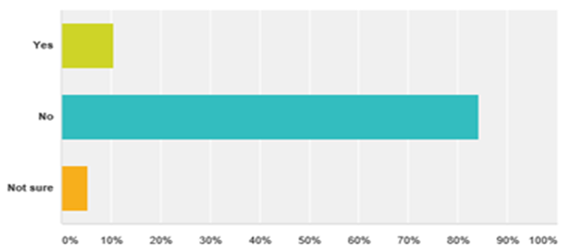

Out of the 19 respondents in Calderdale, 16 were not happy with the level of support they were offered

We asked if people would like more support, and if they did what kind of support that would be.
‘Occupational therapy addressing day to day organisation, planning and decision making. I get very ' stuck' in thought loops and find it hard to move forward practically.’

‘More understanding from GP and a support worker and specific counselling for autism.’

‘I would like more understanding from my doctor as they think I'm just anxious and don't take me seriously.’

‘Eating disorder support at home or within walking distance. Autism specific counselling or autism specific psychotherapy - within walking distance i.e. in Hebden Bridge.’

‘My mental health disorder leads me to suffer pain and I have benefitted in the past from acupuncture, for the pain, stress relief and digestive disorders.’

‘CPN to help with mental health issues.’

‘Better physical health monitoring - needed due to medication.’

‘I would like some occupational therapy to help with my tactile defensiveness and sensory overload and I would like some physical therapy to help me calm down and rest. I think better signposting and generally reduced noise would be supportive.’

‘I would like support to allow/help me learn to relax more as I often get wound up by the situations at work and can't wind down and relax easily.’

We asked for people’s thoughts about what could be done to improve services and support for adults with ASC in Calderdale?
‘Ditch the Wakefield service as the primary source for diagnosis. I feel they don't have the skill to identify very high functioning autistic individuals.’

‘Well there could be a formal service that works with able autistic adults to begin with! Easier access to diagnostic services, locally, post-diagnostic support, ongoing support with mental health and practical issues, ongoing support to access local community. A named care coordinator is necessary, who knows and has a lot of experience around autism and autism related mental health issues. Complex needs services for people who have combinations of autism spectrum conditions, mental health issues and physical disability needs.’

‘Treat us with dignity don’t just think we attention seek and overreact’

‘I think more understanding and awareness from GP's. I'm getting a private assessment and it's difficult to get a referral and a very long waiting list.’

‘Need more support whilst waiting for a diagnosis’

‘Calderdale to stop over medicalising treatment - it is not a mental health condition’

6. Our conclusions

The key overarching findings from the engagement are that:

- There are no clear diagnostic and treatment pathways for adults with ASC in Calderdale. Differences in diagnostic process leaves many adults with ASC requesting a second opinion.

- Adults with ASC find the process required for getting a diagnosis of adult ASC in Calderdale very daunting and stressful.

- People are experiencing significantly long waiting times before assessment and diagnosis

- In some cases, the delay in getting a diagnosis can make it difficult to gain or retain employment, or progress in academic studies, as people may not able to access support or request to have reasonable adjustments made for them.

- Many people with ASC have reported having mental health issues including anxiety, depression, eating disorders and claustrophobia.

- Adults with ASC want more services and support in their local area, as travelling and using public transport can cause serious barriers to access.

- Greater awareness of autism amongst health professionals, and a readiness to meet the needs of adults with ASC, would make a huge difference to the overall experience of those adults.

- There are some simple, quick and low cost adjustments that could be made to help people with ASC access clinical services, e.g. having quiet waiting areas.

- There are some more intensive and specialist services that adults with ASC feel would be useful to them including specific psychological therapy and access to OT’s.

7. Our recommendations

- For Calderdale CCG to use the feedback from people with ASC presented in this report, to help design and commission better services.

- That consideration be given to how GP practices could be made more ASC friendly, including use of the Royal College of GP’s new toolkit of resources.

- That consideration be given to whether the mental health support available in Calderdale is suitable for adults with ASC, or whether adaptations need to be made to enable them to access mental health services.

8. Appendices

Appendix 1 - Calderdale Case Studies

Case study 1 - I paid for a private diagnosis as the process in Calderdale was too daunting!
Last year we started my son’s referral to CAMHS, he is now on the ASD Tier 3 Pathway. I did a lot of research, and found an article about females on the spectrum, this was a lightbulb moment for me. I did the online Autism Spectrum Quotient test in Nov 2016 and was surprised by my high score.

I was already aware of the Calderdale National Autistic Society Facebook group, but I also got in touch with Dawn Whiteley who explained the different routes that can be taken to get a diagnosis, and also the differing diagnosis rates depending on which area did the assessment. I also went to some of the peer support groups and talking to people which really helped.

My GP put everything down to anxiety, and as I had already had a course of CBD and counselling with no mention of ASC, I didn’t feel I could ask for a referral, also I was always being seen by different doctors.

I didn’t want to go through the whole process especially if there was only a small chance of a positive diagnosis, but Dawn told me about the option of a private diagnosis. I only had to wait one month for Sheffield to assess me, I had one appointment of about 3 hrs, and completed 2 questionnaires beforehand. It was a really good experience, they made accommodations for my needs, were easy to talk to, and it was worth the £500 it cost to finally get a diagnosis.

The reason I wanted a diagnosis was that I needed to be sure about it as people have commented and are surprised, also the diagnosis makes me feel more confident in myself. Now I know why CBT didn’t work but I can now look at other things that might work, and I have already found ways to manage it.

If I had known younger could have made a big difference, I never knew who I was, now it all makes sense. I now feel very positive and I am talking to other people about it, and can help other people, and I want things to change for the better.

Case study 2 – Long waiting time to get correct diagnosis
In February 2014, I approached my GP to request a referral for a diagnosis of an Autism Spectrum condition (ASC). Following a referral to the Calderdale Lower Valley Community Mental Health Team to be assessed by a Psychiatrist, the funding for my assessment by the Wakefield Service for Adults with ADHD/Autism was approved in April 2014, although I had requested a referral to Sheffield Adult Autism and Neurodevelopmental Service (SAANS).

I contacted Wakefield to ask how long the waiting list was following my referral because I was worried about disability support whilst at University. I was informed that I was not on the waiting list because they hadn’t received confirmation of my funding. When I got confirmation of my funding I was told I would have to wait around 12 months for an appointment, and I was extremely upset because I couldn’t get the correct support at University or reasonable adjustments at work without an official diagnosis.

I was finally seen at Wakefield in March and April 2015, and was told that I did not meet the criteria for an ASC and it was suggested I might have Social Anxiety Disorder instead. I researched the signs and symptoms of SAD and asked close family members to tick which, if any, of the signs or symptoms they had witnessed. Of the symptoms only those that could also be autistic traits were agreed upon. It was at this point I decided to ask for a second opinion, in July 2015.

By this time, the stress of the whole process had begun to take its toll on my mental health. The last straw was when I received notification in December 2015 that funding for a 2nd opinion would not be granted. The day after I had a meltdown at work and was signed off sick for two weeks by my GP. When I returned to work, I was disciplined and I decided that I could no longer cope with work and resigned.

My GP and I challenged the funding decision and I was awarded funding for a second opinion in March 2016 and referred to SAANS where I finally received my ASC diagnosis in August 2016.

Unfortunately, I am still suffering the consequences of these events. I applied for another year funding to go back to University under Compelling personal reasons and was successful, my mental health had improved and I now have the Autism diagnoses which would enable me to access the correct support, but then my husband lost his job because of the toll this process had on me, and my reaction to it, affected his psychological wellbeing.

Had my initial request to be sent to SAANS been granted I would have been seen by them in November/December 2014 and I would not have had to endure the constant battle for a diagnosis for 2 and half years. This delay, which was caused by the application of the diagnostic pathway policy of South West Yorkshire Partnership NHS Foundation Trust, has consequently lead to increased psychological distress with subsequent loss of earnings and increased debt.

Case study 3 - Long waiting time and now awaiting funding for second opinion
From the very start I was labelled clumsy, difficult, obstinate, idle, lazy, anti-social, morose, depressed etc. by my parents and teachers, and later I was diagnosed with chronic anxiety, and then personality disorders.

In June 2013 I saw a new psychiatrist who suggested that I was on the autistic spectrum, and this was backed up by the results of an Autism Spectrum Quotient (AQ) test I took at the Dales. A report was then written up which mentioned the ‘Triad of difficulties’ and this is the only phrase from a psychiatrist that I have ever felt actually summed up the problems I have always experienced from childhood to the present day.

Following the initial diagnosis, I was told I would be seen by a specialist autism clinic, either in Sheffield or Wakefield within the year. In September 2013 Calderdale CCG granted me funding for this assessment and I was finally given a date for the assessment by the Wakefield Service for Adults with ADHD/Autism of September 2016, three years since the original diagnosis. But then at the third session I was informed that I did not have autism/Asperger’s.

My then CPN stated that he had sent other service users to Sheffield for second opinions, and that Sheffield had overturned/rescinded Wakefield opinions.

Consequently, I have asked for a second opinion, and have been verbally informed that the psychiatrist has initially agreed to this, but that getting funding from Calderdale CCG may prove an issue. I have had nothing in writing about this even though it states in my Care Plan from 2014-2016 that I struggle with ‘verbal promises’ so every effort should be made to confirm decisions in writing.

I now feel even more isolated, as it seemed that someone in authority had opened a gate which allowed me to understand the nature, the person, the personality that was and always has been me - without indulging in self-hate, but truly accepting myself without the need to apologise that I wasn’t coming up to everyone else’s desired standards or personality types. This I could never achieve until the ‘triad of difficulties’ statement.

Case study 4 - There is no post diagnostic clinical support
Diagnosis should be the key to accessing the services you need but I have been going round in circles for four years. Four years ago I was formally diagnosed by the Sheffield Autism Service with significant needs but as there are no commissioned services in Calderdale to support adults with ASC I feel like I am stuck in a gap and this has severely affected my ability to lead a fulfilling life.

I wanted to maintain my job, marriage, and academic career, and given reasonable adjustments I can respond well, but ASC has affected the whole of my development. ASC affects my mental health as well, as I suffer from anxiety and can become agoraphobic. I have problems processing information and become overwhelmed easily, and I have difficulty focussing on more than one thing at a time, as I can’t shut down all the areas I am processing to focus on just one.

In May 2015 I had an interim social worker for one year on a commissioned Autism Pathway, this was then meant to be provided by SWYT in Wakefield, but that never happened so I was without coordinated support at huge cost to my mental health. Following this I was signposted to the Adult Social Care Directorate but they tell me that they are not responsible for the outstanding clinical needs I have, and SWYT tell me that they are not getting funding to support my clinical needs.

A big issue for me was poor communication while having my community care assessment reviewed last year, and then being signposted between SWYT and Local Authority services, as well as to services which are not actually commissioned in Calderdale. The poor communication and non-communication between the services that are being delivered by the Trust and myself has been very difficult for me to cope with.
I am just following what I am being instructed to do but find I am going around in circles which is extremely distressing, especially with the complex lifelong conditions I live with, as no appropriate adjustments are being made, or care delivered. It is horrendous being left to navigate through all this on my own as I cannot lead a fulfilling life while all this is going on.

I am unable to get any general advocacy to help me deal with the ongoing issues I am dealing with. I have a Critical Support Plan but no one seems to be taking responsibility for providing support. I am constantly being told what people can’t do for me, and that services are being cut and that there is no money for services. I also feel undermined and misunderstood when I try to explain or complain about the difficulties I am having and people don’t understand or respond when they say they will.

I am appalled at how little Autism Awareness there is in the statutory services - they need to have awareness, knowledge and training about ASC and to make reasonable adjustments when communicating with people they know are on the spectrum. People with ASC need a consistent, informed, joined-up multidisciplinary team approach to support them to achieve their potential. People with ASC should not have to do all the legwork themselves, especially when dealing with an out of area service. All the services need to be integrated – welfare, health, education, social services – and gaps identified and addressed.

Postscript:
After a very distressing and stressful day, I came home and I had a complete meltdown while trying to get something to eat absolutely shattered and overloaded I couldn’t process making anything to eat and I was in a terrible state.

I tried to reach out 3 times to the home based treatment team for some help but they just asked me to call my key worker next week even though I explained I don’t have one. I proceeded to call 999 - the ambulance service came to my home and assisted me to make some food and they talked to me properly and assisted me to be re-orientated and they were brilliant. I am not clear what the out of hours home based treatment team are there to do. I told them I was feeling in a critical state of mood and I even asked them to call for some help - they told me to do it myself.

The ambulance service did me more justice in the half an hour they were with me in my home than the other services have been doing over the last few years on the whole. They suggested I could phone them anytime if I need their help and they really listened to me and comforted me and they certainly looked out for me. So is that how I am now meant to get any out of hours needs met from now on - I call 999?

Case study 5 – ASC means I see, feel, and sense the world differently
I self-harmed for years. For years I never sought medical attention because I was so afraid of being locked up or put on medication. I have never lived in one place longer than a year until recently, because of noise or social anxiety or not being able to pay the rent. I have not been able to hold down a job or earn enough through self-employment to live.

I am too scared to ring and ask for help because when I do people ask a thousand questions and it’s like I have to get diagnosed or prove I need help all over again. The only support I get I have to go through a very stressful experience to get which is filling out forms and there is no help to do this.

I only went for a diagnosis because I was lucky to meet one person who cared about me and saw I needed help, but was not a freak, and took time to see how overwhelmed I was by all the noises and colours and movements around me.

These experiences can mean that I need to leave an environment even if I have an important task to do, and I have not felt able to ask for help or support because sometimes I don’t know how to put it into words especially when I am in overload of distress and I can no longer speak.

It has made me feel that I am sub human. That society would prefer me to be dead. That I am a waste of time. Afraid. Alone. suicidal, worthless. Broken. Destroyed. Very sad.

Case study 6 - The noise at the GP surgery is unbearable
I find the music or radio played in the local doctor’s surgery unbearable, yet I am afraid to ask for it to be turned down or off. There is a reason given: they say it helps with patient confidentiality but it is not effective at doing this.

I cannot wait in the surgery for my own or children’s appointments without feeling stressed and punished by the noise.

I find this is also a problem at the swimming pool where I have asked for the music played to be turned down and have met with a sceptical response.

I wish they could understand that it takes a great deal of courage to ask for noise to be turned down and if they agree to do it, they should not show resentment.

They should understand how stressful noise is for some people. The best way of understanding is that certain noises act like allergens: most people do not react at all to, for example, peanuts, but a tiny minority do and for them it is very serious.
The difficulty for people with hyper-sensitivity to noise is that the effect on them is not visible, or measurable. However, we feel as distressed as if listening to a fire alarm or gunfire.

Appendix 2 – Adult Autism Services Survey
Adult Autism Services in Calderdale and Kirklees
Thank you for taking part in this survey.
Healthwatch Calderdale would like to know more about your experiences of being an adult with an Autism Spectrum Condition (ASC) in Calderdale and Kirklees, and the support you get from health, social care and community services. We want to find out what works well and what doesn’t work so well.
We also want to hear from the parents, carers, and partners of adults with ASC. We have created a separate survey for parents, carers and partners which you can complete at this link: Adult Autism Carers Survey - We would like feedback on:
- Your experience of getting a diagnosis, or trying to get one
- The support you get from health, social care or community services
- How easy it is to access the services you need to help you live the life you want
Don't worry if you don't have feedback about all of those things, we would like to hear your feedback on any of these areas, so you can fill in as many or as few questions as you would like to on this survey.
If you have any questions about this survey or if you need any support to complete it, please do not hesitate to give Healthwatch Calderdale a call on 01422 399433, or email info@healthwatchcalderdale.co.uk.
Please note that any views you share will remain confidential, and no personal identifiable information will be shared when reporting on the findings of the engagement.
The deadline for completing this survey is Tuesday 25th April 2017.
- Which area do you live in?
Calderdale
Kirklees
Other (please say)
- Which of these statements best describes you?
I have been diagnosed with an autism spectrum condition
I have an autism spectrum condition but no formal diagnosis
I have had a referral to the Autism Service and am waiting for an assessment
I am the parent/carer of an adult with a diagnosed autism spectrum condition, and I am completing this survey on their behalf.
I am the parent/carer of an adult with an autism spectrum condition but no formal diagnosis, and I am completing this survey on their behalf.
I am the parent/carer of an adult with an autism spectrum condition who has a referral to the Autism Service and is waiting for an assessment, and I am completing this survey on their behalf.
None of the above
Gathering your views
This survey is gathering the opinions of people with autism spectrum conditions and their carers. As you have selected "None of the above" for the previous question, the remaining survey questions would not be applicable to you.
We are still interested in your views on services for adults with autism spectrum conditions in Calderdale. Please feel free to share your views below.
- Which of these statements best describes you?
A professional working with adults with autism spectrum conditions
A volunteer working with adults with autism spectrum conditions
Someone interested in autism spectrum conditions
Other (please specify)
- Please tell us your thoughts about adult autism services in Calderdale and/or Kirklees.

Waiting for an assessment and diagnosis
- Please rate your experience of waiting for an assessment and diagnosis of ASC.
Was it:
Very good
Good
Acceptable
Poor
Very Poor
Please explain your rating:

Your experience of diagnosis and assessment
We would like to know about your experiences of referral, assessment or diagnosis by South West Yorkshire NHS Partnership Foundation Trust (SWYT) Autism Service, also known as the Service for Adults with Autism Spectrum Disorder, based in Wakefield.
- Were you diagnosed through the SWYT Autism Service?
Yes
No
I don't know
- If no, please tell us where you were diagnosed.

- How would you rate your experience of being diagnosed?
Please explain your rating:
Very good
Good
Acceptable
Poor
Very poor
Adult Autism Services in Calderdale and Kirklees
Social Care Assessment
- Following your diagnosis, have you had a Social Care Assessment?
I don't know (please specify)
Yes
No
I don't know
- Please tell us about any support you received following the Social Care Assessment e.g. practical assistance in your home, help with paperwork such as bills and letters, access to recreational facilities such as day centres and drop in clubs, assistance with travelling, supported living or residential care.
Please give details:

- Please rate the support you received:
Very Good
Good
Acceptable
Poor
Very Poor
Please explain the reason for your rating:
Please tell us how having an autism spectrum condition (ASC) affects your life:

- To what extent are these areas of your life are affected by your ASC?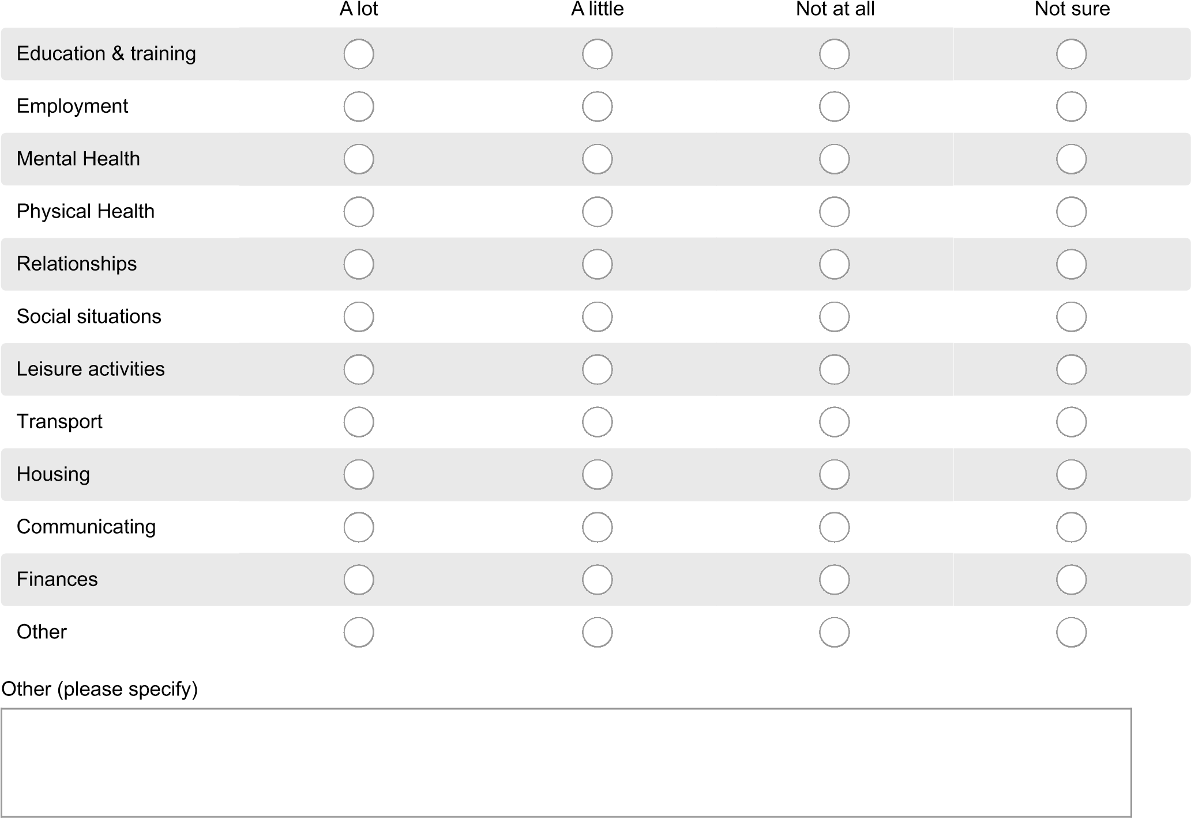
- Please tell us a bit more about the everyday challenges you face because of your ASC, e.g. shopping, going to the doctor, dealing with phone calls, etc.

- To what extent do you get help and support from these people/groups/places?
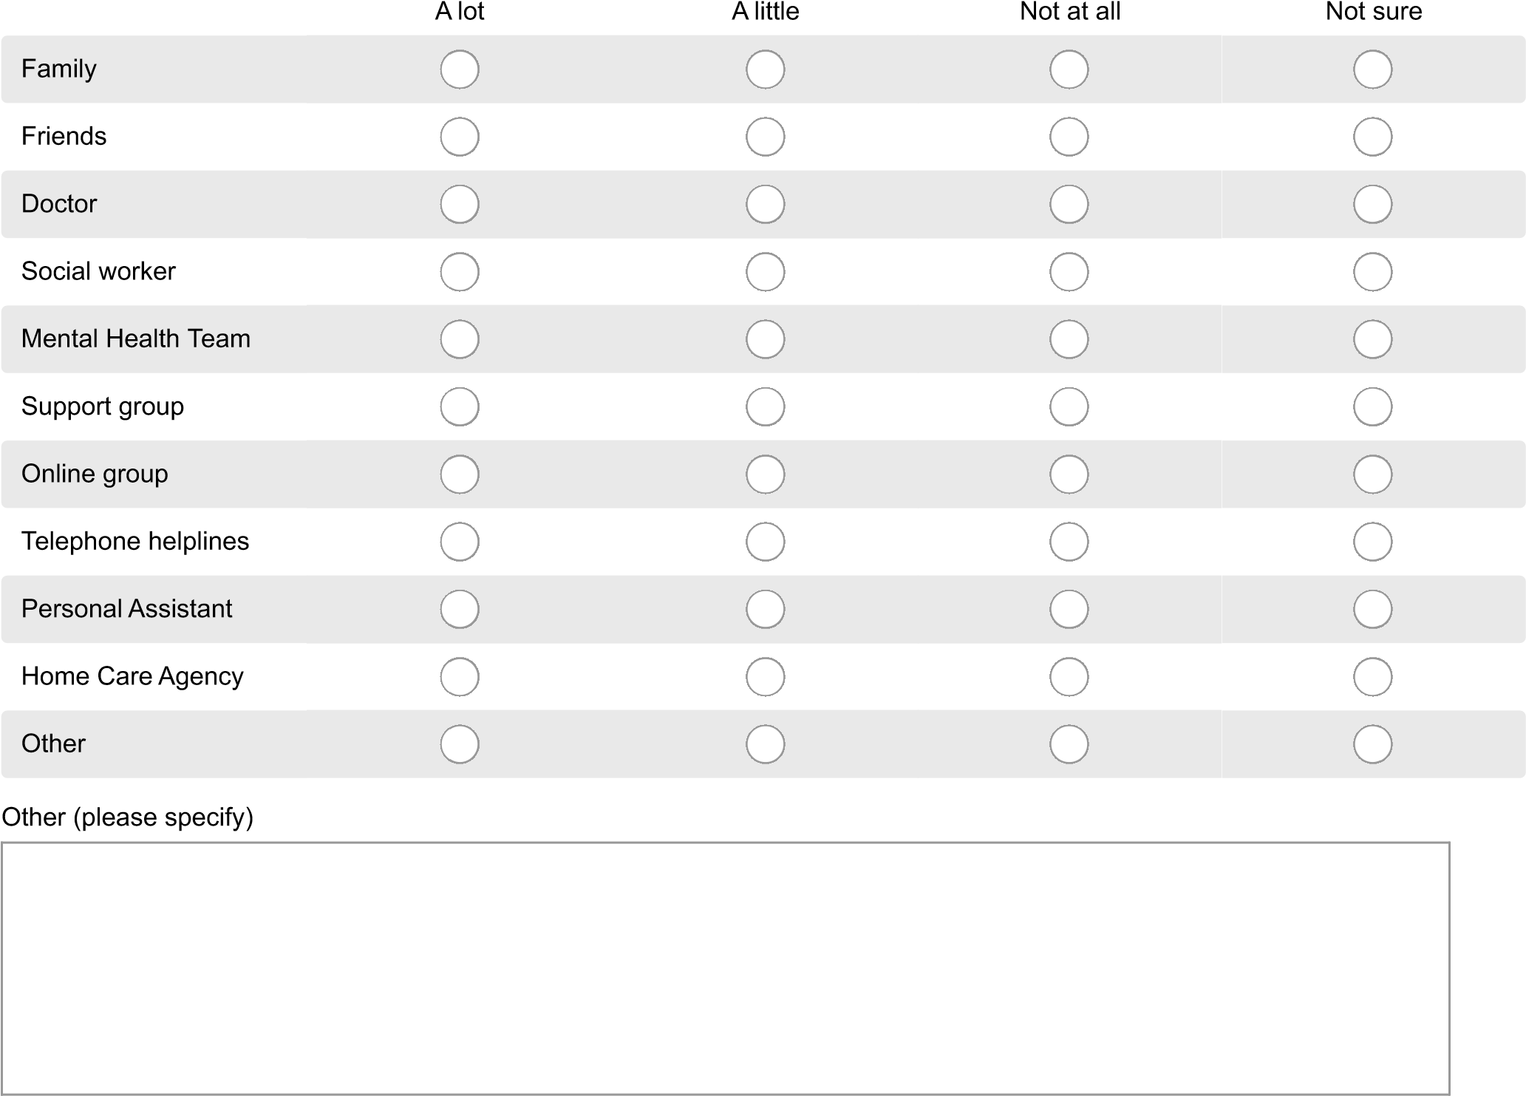
- Do you think you get enough support to help you manage the effects of your ASC?
Yes
No
Not sure
- If you would like more support, please tell us what kind of support that would be.

- What do you think could be done to improve services and support for adults with ASC in your area?

- We would like to collect some real life stories to show how Autism Spectrum Conditions affect people’s lives.
We have a short template you could use to write down your story yourself, please contact Jo Budgen at Healthwatch Calderdale (details below) to get a copy, or if you would prefer us to help you to write it please let us know so that we can arrange to do this.
Jo Budgen, Healthwatch Calderdale, Elsie Whiteley Innovation Centre, Hopwood Lane, Halifax, HX1 5ER Tel: 01422 399433
Email: jo.budgen@healthwatchcalderdale.co.uk
Any part of the case studies that we use will be anonymised, with identifying personal data removed to ensure your confidentiality.
The deadline for collecting peoples personal stories is Tuesday 25th April 2017.
If you would prefer it if we got in touch with you please enter your contact details in box below:

Adult Autism Services in Calderdale and Kirklees
Equality monitoring

It's really important to Healthwatch Calderdale and Healthwatch Kirklees that we ask as broad a range of people as possible for their views . To make sure that we do this, we ask people to give us some information about themselves, and we review this regularly to check we are not discriminating against any group of people by not asking for their views.
If you can, please take the time to give us this information.

- What is the first part of your postcode? e.g. HD1, WF10, BD4, LS13, HX6
If you would prefer not to say, please leave the box blank

- What sex are you?
Male Female Prefer not to say
- How old are you? e.g. 42
If you would prefer not to say, please leave the box blank

- Which country were you born in?
If you would prefer not to say, please leave the box blank

- Do you belong to any religion?
Buddhism
Christianity
Hinduism
Islam
Judaism
Sikhism
No religion
Prefer not to say
Other (please specify)

- What is your ethnic group?
Asian or Asian British: Indian
Asian or Asian British: Pakistani
Asian or Asian British: Bangladeshi
Asian or Asian British: Chinese
Black or Black British: Caribbean
Black or Black British: African
Mixed or multiple ethnic groups: White and Black Caribbean
Mixed or multiple ethnic groups: White and Black African
Mixed or multiple ethnic groups: White and Asian
White: English, Welsh, Scottish, Northern Irish, British
White: Irish
White: Gypsy or Irish Traveller
Other ethnic groups: Arab
Prefer not to say
Any other ethnic group
- Do you consider yourself to be disabled?
Yes No Prefer not to say
- Types of impairment:
If you selected yes to the question above, please tick all that apply
Physical or mobility impairment (such as using a wheelchair to get around and / or difficulty using your arms)
Sensory impairment (such as being blind / having a serious visual impairment or being deaf / having a serious hearing impairment)
Mental health condition (such as depression or schizophrenia)
Learning disability (such as Downs syndrome or dyslexia) or cognitive impairment (such as autism or head-injury)
Long term condition (such as cancer, HIV, diabetes, chronic heart disease, or epilepsy)
Prefer not to say

- Are you a carer?
Do you look after, or give any help or support to a family member, friend or neighbour because of a long term physical disability, mental ill-health or problems related to age?
Yes No Prefer not to say
- Are you pregnant?
Yes No Prefer not to say
- Have you given birth in the last 6 months?
Yes No Prefer not to say
- What is your sexual orientation?
Bisexual (both sexes)
Gay (same sex)
Heterosexual/straight (opposite sex)
Lesbian (same sex)
Other
Prefer not to say
- Are you transgender?
Is your gender identity different to the sex you were assumed at birth?
Yes No Prefer not to say

Again, thank you for taking the time to complete this survey today.
Healthwatch Calderdale is pulling together all the feedback that people have shared with Healthwatch across Calderdale and Kirklees. Please note that any views you share will remain confidential, and no personal identifiable information will be shared when reporting on the findings of the engagement.
If you would like to know more about the results of this survey or if you want more information about what will happen to your feedback please contact us info@healthwatchcalderdale.co.uk

Appendix 3 – Adult Autism Services, Parents Partners and Carers Survey
Adult Autism Services in Calderdale and Kirklees - survey for parents, partners and carers
Thank you for taking part in this survey.
Healthwatch Calderdale would like to know more about your experiences of being a parent, partner or carer for an adult with an Autism Spectrum Condition (ASC) in Calderdale and Kirklees. We would like to find out about the issues you face and the support you get, including what works well and what doesn't.
We also want to hear from adults with ASC, so we have created a separate survey for them which can be accessed via this link: Adult Autism Survey
We would like feedback on:
- Your experience of supporting an adult with ASC in Calderdale and Kirklees.
- The support you get from health, social care or community services as a parent, partner or carer of an adult with ASC.
- Any ideas you might have that could improve the services and support for adults with ASC and their parents, partners and carers.
Don't worry if you don't have feedback about all of those things, we would like to hear your feedback on any of these areas, so you can fill in as many or as few questions as you would like to on this survey.
If you have any questions about this survey or if you need any support to complete it, please do not hesitate to give Healthwatch
Calderdale a call on 01422 399433, or email info@healthwatchcalderdale.co.uk
Please note that any views you share will remain confidential, and no personal identifiable information will be shared when reporting on the findings of the engagement.
The deadline for completing this survey is Tuesday 25th April 2017.
- Which area do you live in?
Calderdale
Kirklees
Other (please say)
- Which of these statements best describes you?
I am the parent/partner/carer of an adult with a diagnosed autism spectrum condition
I am the parent//partner/carer of an adult with an autism spectrum condition but no formal diagnosis
I am the parent/partner/carer of an adult with an autism spectrum condition who has a referral to the Autism Service and is waiting for an assessment
Adult Autism Services in Calderdale and Kirklees - survey for parents, partners and carers
Waiting for an assessment and diagnosis

- Please rate the experience of waiting for an assessment and diagnosis for an adult with ASC.
Was it :
Please explain your rating:
Very good
Good
Acceptable
Poor
Very poor
The experience of diagnosis and assessment for adults with ASC
We would like to know about the experiences of assessment or diagnosis by South West Yorkshire NHS Partnership Foundation Trust (SWYT) Autism Service, also known as the Service for Adults with Autism Spectrum Disorder, based in Wakefield.
- Did your partner/relative receive their ASC diagnosis through the SWYT Autism Service?
Yes
No
I don't know
- If no, please tell us where he/she was diagnosed.

- How would you rate their experience of being diagnosed?
Please explain your rating.
Very good
Good
Acceptable
Poor
Very poor
Social Care Assessment
- Following their diagnosis, have they had a Social Care Assessment?
I don't know (please specify)
Yes
No
I don't know
Support following Social Care Assessment
- Please tell us if they have received any support following their Social Care Assessment, e.g. practical assistance around the home, help with paperwork such as bills and letters, access to recreational facilities such as day centres and drop in clubs, assistance with travelling, access to supported living or residential care.
Please give details:
- Please rate the support they received:
Please explain the reason for your rating:
Very good
Good
Acceptable
Poor
Very poor
Have you been offered or requested a Carers Assessment?
- Many carers are entitled to have their needs assessed by social services and support put in place to meet eligible needs. Have you had a Carers Assessment to assess your needs as a carer?
I don't know (please specify)
Yes
No
I don't know
Support for Carers
- Were you found to be eligible for support following the Carers Assessment?
Yes
No

Support offered to Carers
12
.

What support were you offered?
- How would you rate the support you were offered?
Please explain your rating:
Very good
Good
Acceptable
Poor
Very poor
Tell us about your experience of supporting an adult with ASC
- Please tell us a bit about the everyday challenges you face as someone who lives with or cares for an adult with ASC.

- If you would like more support to help deal with these challenges please tell us what kind of support that would be.

- What do you think could be done to improve services and support for adults with ASC and the people who care for them in your area?

Equality monitoring
It's really important to Healthwatch Calderdale and Healthwatch Kirklees that we ask a diverse group of people for their views about these initiatives. To make sure that we do this, we ask people to give us some information about themselves, and we review this regularly to check we are not discriminating against any group of people by not asking for their views.
If you can, please take the time to give us this information.
- What is the first part of your postcode? e.g. HD1, WF10, BD4, LS13, HX6
If you would prefer not to say, please leave the box blank

- What sex are you?
Male Female Prefer not to say
- How old are you? e.g. 42
If you would prefer not to say, please leave the box blank

- Which country were you born in?
If you would prefer not to say, please leave the box blank

- Do you belong to any religion?
Buddhism
Christianity
Hinduism
Islam
Judaism
Sikhism
No religion
Prefer not to say
Other (please specify)
- What is your ethnic group?
Asian or Asian British: Indian
Asian or Asian British: Pakistani
Asian or Asian British: Bangladeshi
Asian or Asian British: Chinese
Black or Black British: Caribbean
Black or Black British: African
Mixed or multiple ethnic groups: White and Black Caribbean
Mixed or multiple ethnic groups: White and Black African
Mixed or multiple ethnic groups: White and Asian
White: English, Welsh, Scottish, Northern Irish, British
White: Irish
White: Gypsy or Irish Traveller
Other ethnic groups: Arab
Prefer not to say
Any other ethnic group
- Do you consider yourself to be disabled?
Yes No Prefer not to say

- Types of impairment:
If you selected yes to the question above, please tick all that apply
Physical or mobility impairment (such as using a wheelchair to get around and / or difficulty using your arms)
Sensory impairment (such as being blind / having a serious visual impairment or being deaf / having a serious hearing impairment)
Mental health condition (such as depression or schizophrenia)
Learning disability (such as Downs syndrome or dyslexia) or cognitive impairment (such as autism or head-injury)
Long term condition (such as cancer, HIV, diabetes, chronic heart disease, or epilepsy)
Prefer not to say
- Are you a carer?
Yes No  - Are you pregnant?  Yes No  - Have you given birth in the last 6 months?  Yes No |  | Prefer not to say  Prefer not to say  Prefer not to say
Do you look after, or give any help or support to a family member, friend or neighbour because of a long term physical disability, mental ill-health or problems related to age?

- What is your sexual orientation?
Bisexual (both sexes)
Gay (same sex)
Heterosexual/straight (opposite sex)
Lesbian (same sex)
Other
Prefer not to say
- Are you transgender?
Is your gender identity different to the sex you were assumed at birth?
Yes No Prefer not to say
Again, thank you for taking the time to complete this survey today.
Healthwatch Calderdale is pulling together all the feedback that people have shared with Healthwatch across Calderdale and Kirklees. Please note that any views you share will remain confidential, and no personal identifiable information will be shared when reporting on the findings of the engagement.
If you would like to know more about the results of this survey or if you want more information about what will happen to your feedback please contact us info@healthwatchcalderdale.co.uk

Contents

